Assignment 8

Q8

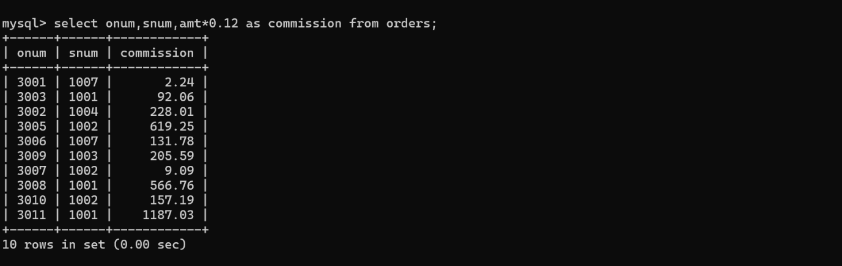

Q2

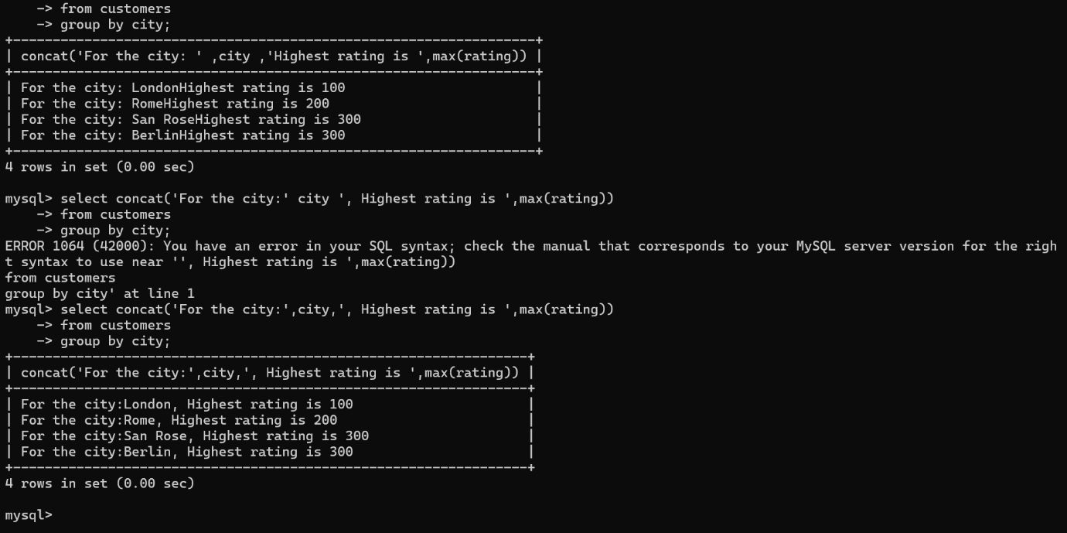

Q3

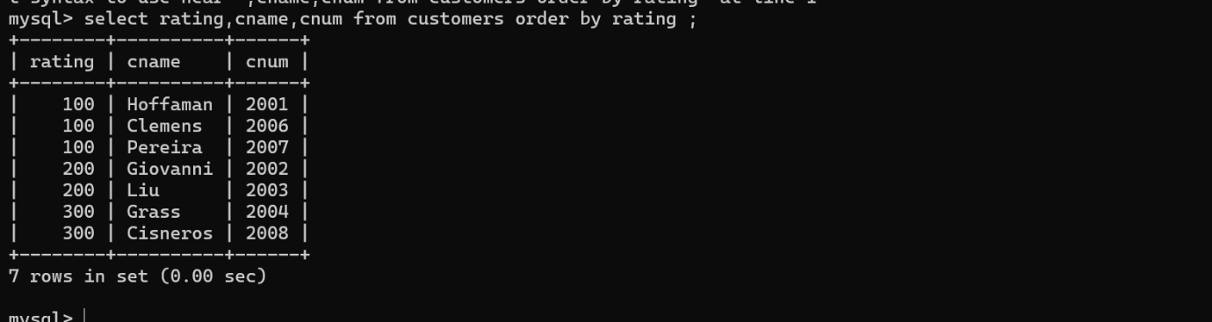

Q4

